Kingsway Together
How would you bring Kingsway Together?  Do you have an idea that will help bring Kingsway Together?  Do you need up to £2,000 to put your idea into action?  If your answers are ‘Yes’, ‘Kingsway Together’ is for you, and can make your project happen.  Deadline for applications is Friday 20th November 2015  For more information visit:  www.cheshire-pcc.gov.uk, email kingswaytogether@cheshire.pnn.police.uk or call 101 and ask for Clare Harrison  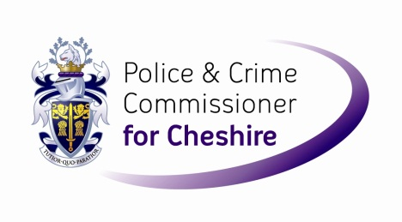  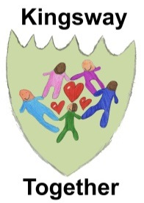 | 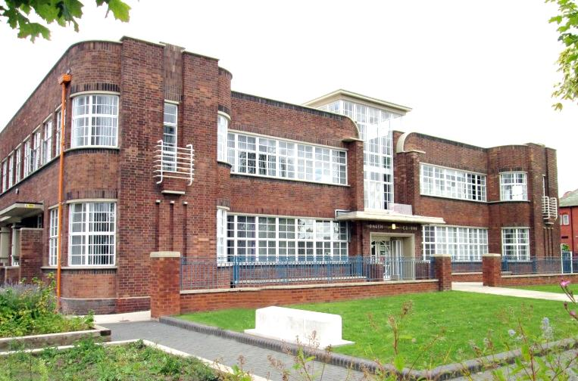
 | 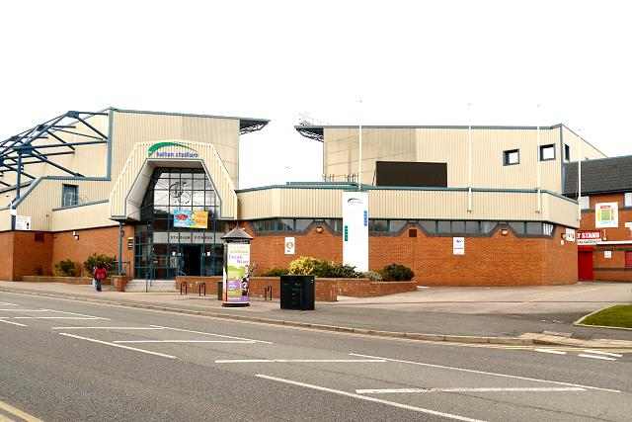
 | 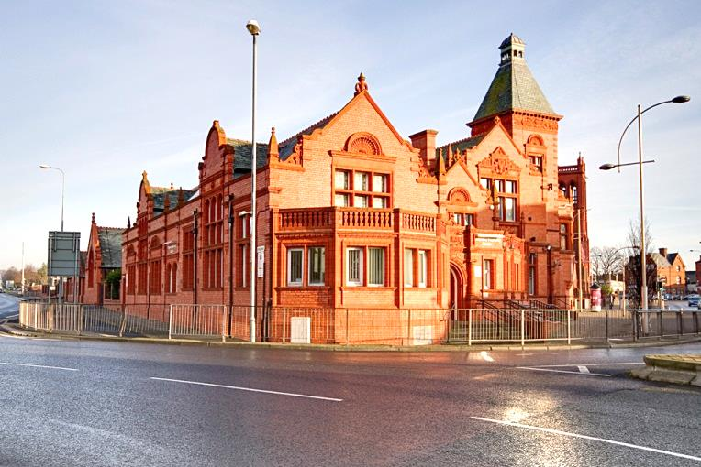

Who can apply?
Any local community, voluntary or non-profit organisation – even informal groups of friends and neighbours – can apply for up to £2,000 to put their ideas into action.

You don’t have to come from an existing organisation to apply for this fund but all activities will have to happen in the Kingsway area or benefit the residents of Kingsway.
Cheshire Police & Crime Commissioner, John Dwyer, has set aside £20,000 for the Kingsway Together project - and wants to put you in control of how it’s spent.

‘Kingsway Together’ lets the local community decide for themselves which projects are needed in their area.

What can you apply for?
We need your ideas for projects that will:
- Benefit as many people as possible from across the community
- Help to make Kingsway a better place for everyone
- Meet a real need that is not already met in the area

Whether you want to organise a dance for young people, a healthy living project, a crime prevention idea, a community art project or a street party for your neighbours, the only limit is your imagination.

If you can convince your neighbours that your idea is a good one, you will get the cash!
How do you apply?
To apply for the funding you must return this form before Friday 20th November 2015.

If your idea fits, local residents will get to vote for the best ideas from 14th December until 30th December 2015. The winners will be announced on Friday 8th January 2016.
REGISTER YOUR IDEA: APPLY TODAY

Full name:
If you represent an organisation what is its’ name?
Address where we can write to you. (Your own address or the address of the organisation you represent)
Postcode: |  |  |  |  |  |  |  |  |  |  |  |  |  |  | Phone number:
Email:
Name of the project:
Briefly describe the project you would like funding for: (max. 500 words)
In a maximum of 50 words, summarise your project (this information will be used on the voting form).
Where will the project take place?

How will the project make Kingsway a better place for everyone?
How many people do you think will benefit from your project?
What particular need will it address for the community?
How much money do you require and what will you spend it on?
Item  PLEASE GIVE A FULL BREAKDOWN OF THE COSTS OF YOUR PROJECT AND WHEN YOU EXPECT TO SPEND THE MONEY BY | Cost | To be spent by
TOTAL

If you are successful you will be required to supply copies of relevant documents e.g. Disclosure and Barring Services (DBS) check as necessary. Please return this form via email to kingswaytogether@cheshire.pnn.police.uk or post it to: Clare Harrison, Engagement Department, Cheshire Constabulary, Clemonds Hey, Oakmere Road, Winsford, Cheshire CW7 2UA

CLOSING DATE FOR APPLICATIONS: Friday 20th November 2015

If you need help completing this form, or would like to discuss your idea before applying, please contact Clare Harrison at the email address above or by calling 101.

